The 8th of March

History of the International Women`s day

This holiday was appeared as a day of struggle for women`s rights. On the 8th of March, 1857 in New York the US gathered at the manifestation of sewing workers and shoe factories. They demanded a 10 hour day and equal male salaries. Men managed to achieve the introduction of a 10 hour day after strong performances. In the U.S. there were many trade Union organizations. In 1910, at the International Conference of Women socialists in Copenhagen, Clara Zetkin proposed the celebration of the International Women`s day. It sounded as a call to all women of world to join the struggle for equality. Responding to this call, women were involved in the tight against poverty and respect for their dignity.

Kubaeva Dasha

March 2017

First sounds of melting snow,
Last snowstorm
It’s holiday of early spring
Of happiness, health, love and dream!

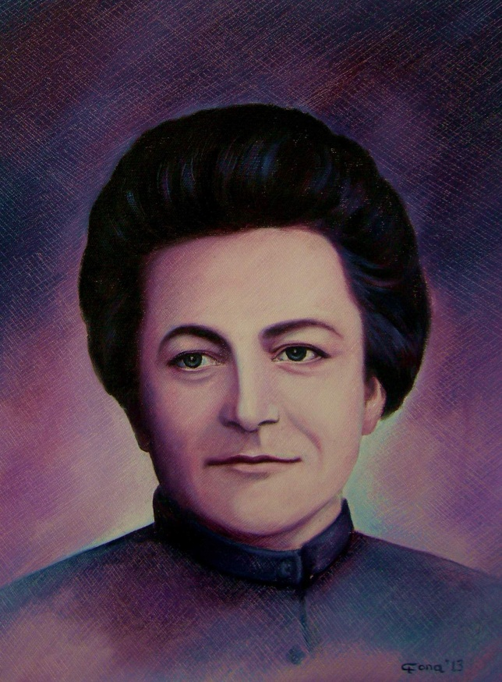

Mother of the International Women’s day

March 8 was introduced in 1901 in America. On this day, American Housewives went to the streets of Chicago with pots and pans. They wanted to draw attention to them. The attempt was repeated after 7 years. National Women's day was proclaimed after that. Clara Zetkin is a mother of the International Women's day. The 8th of March was celebrated from 1975. This year was declared the International Women's year. In Russia this holiday was celebrated for the first time on the 2nd of March in St. Petersburg. At that time women did not receive the flowers and gifts, but they left early from work. National Women's day was officially included in the list of state holidays of the Russian Federation in 2002.
Zheglova Masha

What do women want?

All the girls want to get gifts for the 8 of the March. For some, it is not a very important holiday and it is enough to celebrate them only with words, but for somebody gifts are very important.

TOP 10 gifts for the International Women`s Day:
- Flowers
- Sweets
- Perfume
- A teddy bear
- Tickets to the cinema (theatre, concerts)
- Jewelry
- A dinner in the restaurant for two
- A subscription to the spa salon
- A gift card to the clothing store
- iPhone 7

Choose, reflect, dear men!

The picture made by Korelin Egor

Kuzmina Katya

Dear women!

The 8th of March is a world famous holiday for glorious women. On this beautiful spring day, let us congratulate you on this wonderful holiday – International Women`s Day! This holiday is celebrated all over the country in the first spring month. It is a holiday of spring and at the same time a holiday for all women – our dear mothers, sisters and, of course, teachers!
And today, we congratulate all our teachers and women on this great holiday. With all our love we wish you success, happiness, joy, love, many sweets and flowers. May all your dreams come true and may your lives be peaceful! Feel special and unique! Let the harmony and colors shine in your life!
Happy Women`s day to you!
Morozkova Polina

